1

1.1 intitle: zone inurl: dns

1.2 ‘allintext’ command can query for multiple terms, which will return documents that contains those terms in the text.

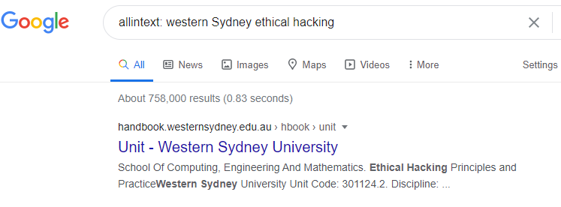

2

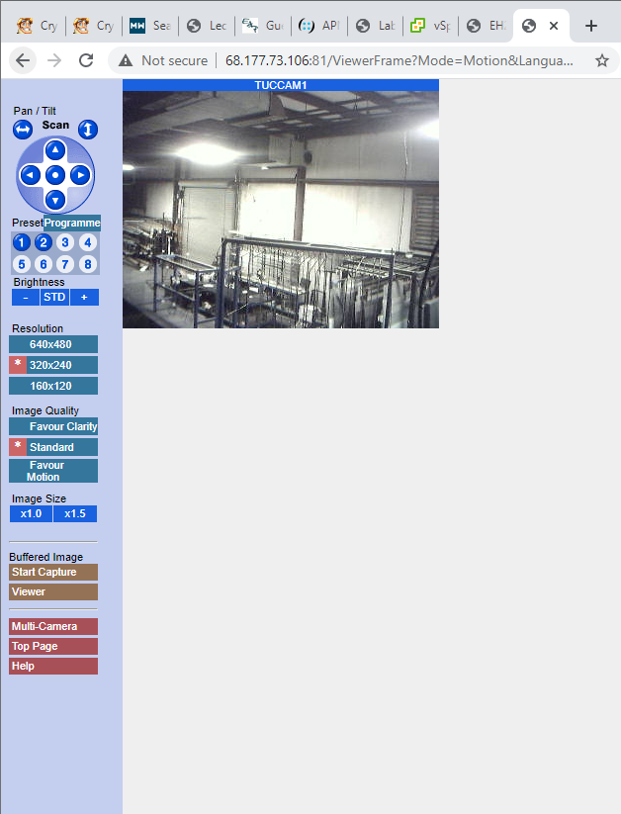 2.1

2.2

3

3.1 Fairfax Metro Pty Limited

3.2 whois command will query ‘transportnsw.info’ domain, and gets information such as registrant, registration Id and etc and it will then redirect the output ( > ) to ‘whois.txt’

3.3 grep -I does a case insensitive search in ‘whois.txt’ for a term matching registrant. ‘i’ is to match all the words case insensitively.

3.4 Transport NSW

4

4.1 No

4.2 different NS servers

4.3 North America: American Registry for Internet Numbers

4.4

a) Xerox Corporation

b) 13.0.0.0 - 13.23.255.255

5

5.1 whitegum.uws.edu.au

5.2 > set type=mx

>gmail.com

gmail.com MX preference = 40, mail exchanger = alt4.gmail-smtp-in.l.google.com

gmail.com MX preference = 5, mail exchanger = gmail-smtp-in.l.google.com

gmail.com MX preference = 20, mail exchanger = alt2.gmail-smtp-in.l.google.com

gmail.com MX preference = 10, mail exchanger = alt1.gmail-smtp-in.l.google.com

gmail.com MX preference = 30, mail exchanger = alt3.gmail-smtp-in.l.google.com

> set type=A

> alt1.gmail-smtp-in.l.google.com

Non-authoritative answer:

Name: alt1.gmail-smtp-in.l.google.com

**Address: 173.194.202.26**

> alt2.gmail-smtp-in.l.google.com

Non-authoritative answer:

Name: alt2.gmail-smtp-in.l.google.com

**Address: 74.125.137.27**

> alt3.gmail-smtp-in.l.google.com

Non-authoritative answer:

Name: alt3.gmail-smtp-in.l.google.com

**Address: 142.250.138.27**

> alt4.gmail-smtp-in.l.google.com

Non-authoritative answer:

Name: alt4.gmail-smtp-in.l.google.com

**Address: 173.194.200.26**

> gmail-smtp-in.l.google.com

Non-authoritative answer:

Name: gmail-smtp-in.l.google.com

**Address: 172.217.194.26**

5.3

> server 8.8.8.8

Default Server: dns.google

Address: 8.8.8.8

> set type=A

> gmail.com

Server: dns.google

Address: 8.8.8.8

Non-authoritative answer:

Name: gmail.com

Address: 172.217.167.69

5.4

Non-authoritative answer:

Name: alt1.gmail-smtp-in.l.google.com

**Address: 173.194.202.27 // Different Address**

Non-authoritative answer:

Name: alt2.gmail-smtp-in.l.google.com

**Address: 74.125.137.26 // Different Address**

Non-authoritative answer:

Name: alt3.gmail-smtp-in.l.google.com

**Address: 142.250.138.27 // same as before**

Non-authoritative answer:

Name: alt4.gmail-smtp-in.l.google.com

**Address: 173.194.200.26 // same as before**

Non-authoritative answer:

Name: gmail-smtp-in.l.google.com

**Address: 74.125.24.27 // Different Address**

6

1. 'dig gmail.com mx +short’ Find out the Email server for a domain.

Domain: gmail.com

Mx: Find the Email server for a domain.

'+short': makes the output concise.

b. @8.8.8.8 means the server we want to query in, which is 8.8.8.8 server.

c. 5 servers are returned.